Workshop3

# **Jobseeker - Jobs List**

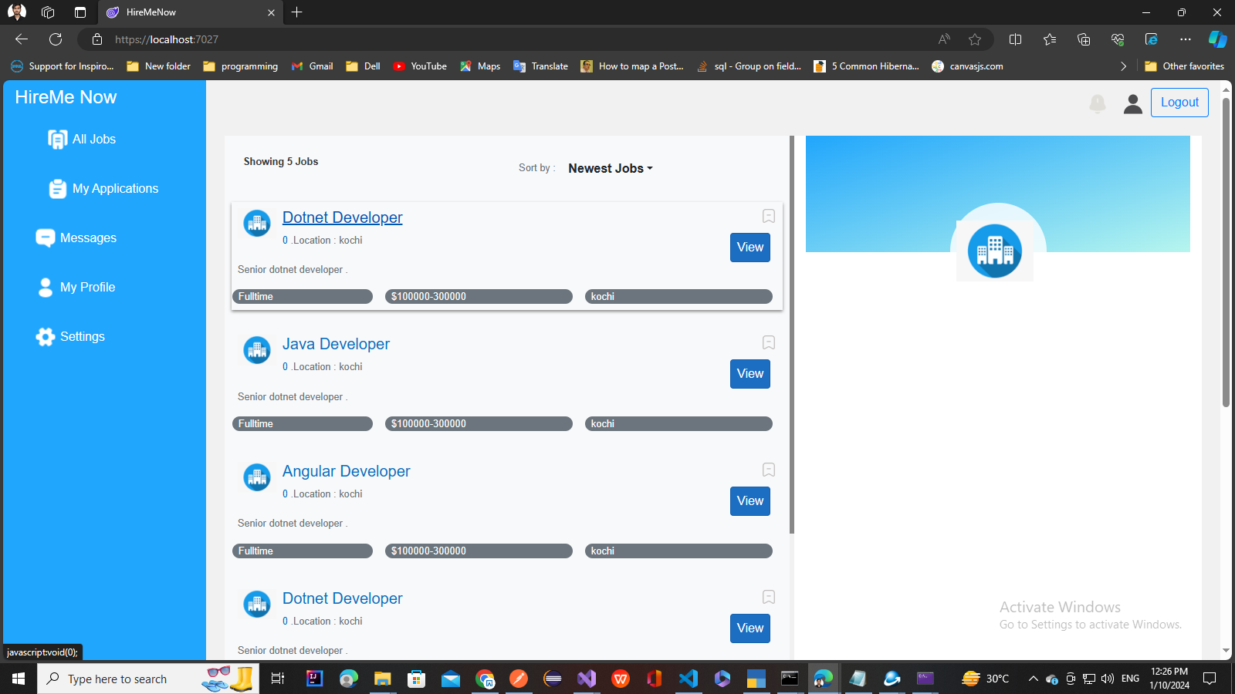

## 

### **Overview:**

Blazor is a framework for building interactive web applications using C# and .NET. In this workshop, we'll explore the fundamentals of Blazor by creating an job list page for a job portal application.

### **Workshop Goals:**

* Understand the basics of Blazor and its components
* Create a job list page using Blazor components
* Implement functionality for the job seeker job list page(Listing)

### **Prerequisites:**

* Basic knowledge of C# and .NET Core
* Familiarity with HTML, CSS, Bootstrap and JavaScript

### **Workshop Agenda:**

#### Part 1: Introduction to Blazor

* What is Blazor?
* Blazor hosting models (Server-side and WebAssembly)
* Benefits of using Blazor for web development

#### Part 2: Setting Up the Project

* Clone the Application and open in Visual studio
* Go through the Project structure overview

#### Part 3: Go through Components and Check How Dependency Injection works

#### JobComponent

* ListJobComponent

#### Part 4: Go through layout page (JobSeekerLayout) and Its Implementation

* Change background color
* Change App Title to HireMeNow!

#### Part 5: verify Implementation of Apply Job functionality in JobComponent

### **Resources:**

* Visual Studio or Visual Studio Code
* .NET Core SDK

### **Conclusion:**

Blazor offers a powerful way to build interactive web applications using .NET. By creating an admin job list page, you've explored the basics of Blazor components, data binding, and functionality implementation. Continue exploring Blazor to unleash its full potential in web development.